**Ejercicio 1**

Dibujamos los posibles caminos a probar:

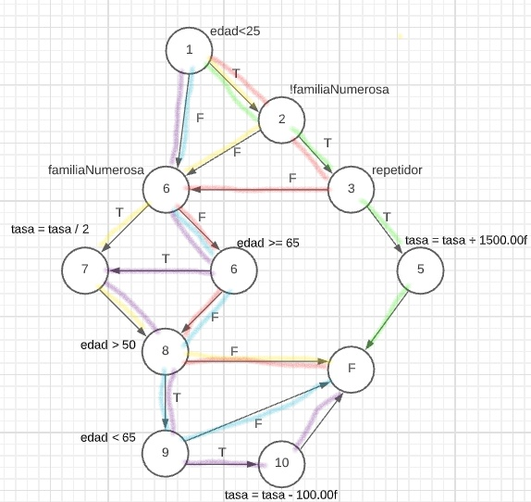C1

C2

C3

C4

C5

**CC** = 17 – 11 + 2 = 8

**C1** = 1 U 2 U 6 U 7 U 8 U F  
**C2** = 1 U 2 U 3 U 5 U F

**C3** = 1 U 2 U 3 U 6 U 6 U 8 U F

**C4** = 1 U 6 U 6 U 8 U 9 U F

**C5** = 1 U 6 U 6 U 7 U 8 U 9 U 10 U F

|  |  |  |  |
| --- | --- | --- | --- |
| Casos de  prueba | Datos entrada | | |
| Edad | FamiliaNumerosa | Repetidor |
| C1 | 22 | True |  |
| C2 | 22 | False | true |
| C3 | 22 | false | flase |
| C4 | 55 | false |  |
| C5 | 80 | false |  |